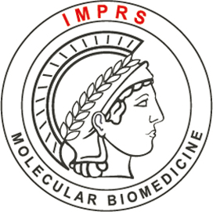
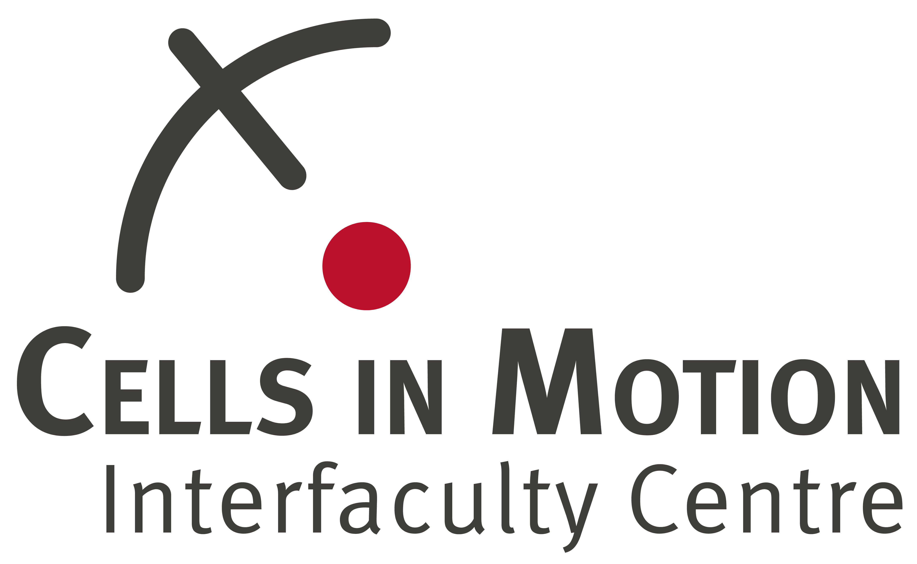

Joint PhD program of the University of Münster and the
Max Planck Institute for Molecular Biomedicine

16 PhD Positions in Münster (Germany): Imaging Cellular Processes and Disease
The joint CiM-IMPRS graduate program of the International Max Planck Research School - Molecular Biomedicine and Münster’s Cells in Motion Interfaculty Centre offers positions to pursue PhD projects in the life sciences. We are looking for early career scientists with a vivid interest in interdisciplinary projects to image cell dynamics from the subcellular to the patient level. PhD projects range from the analysis of basic cellular processes to clinical translation, from the application of novel biophysical approaches and the generation of mathematical models to the development of new imaging-related techniques and compounds.

Research areas:
Cell and Molecular Biology * Developmental and Stem Cell Biology
Vascular Biology * Immunology
Biophysics * Neurobiology
In vivo Imaging * High Resolution Optical Imaging
and more.
Applications for the PhD program can be submitted from 5 February to 7 April 2024. Projects start in October 2024 (earlier starts are possible if desired). Applications can only be submitted via our online system.
For online application and further information go to:
www.cim-imprs.de
We offer 16 fully financed PhD positions. More positions financed by work contracts may be offered depending on availability. Excellent scientific and transferable skills trainings, competitive work contracts or tax-free fellowships as well as support with administrative matters, accommodation, and visas are part of the program. There are no tuition fees. The program language is English. We invite applications from highly qualified and motivated students of any nationality from biological sciences, chemistry, mathematics, computer sciences and physics. Be part of CiM-IMPRS, a program run jointly by the University of Münster and the Max Planck Institute for Molecular Biomedicine.

Contact: cim-imprs@uni-muenster.de

